## **LMS Survey**

The LMS survey was conducted using Survey monkey in the hopes of getting the largest amount of customer feedback possible, which could help us validate some of the ideas we already had and eliminate the invalid ones.

The LMS survey received replies from 10+ respondents and counting at the time of this report, the survey included 10 questions.

After performing some data analysis on the questions, we have reached the conclusion that we need to eliminate some of the ideas we had and only focus on the communication aspect of the problem, we would also add an additional idea to meet the needs of our respondents by creating a standalone canvas messenger application called “Canvas-Me”, This idea was further re-enforced upon talking to some of our interviewees.

### **Survey questions statistics**

#### **Question 1**

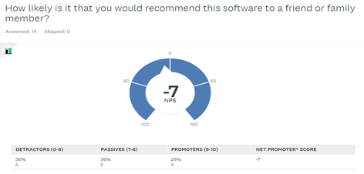

#### **Question 2**

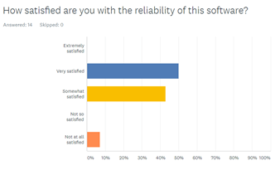

#### **Question 3**

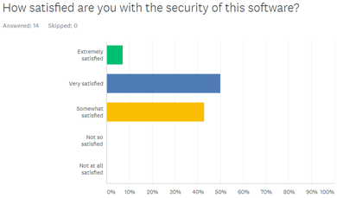

#### **Question 4**

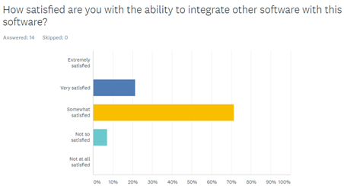

#### **Question 5**

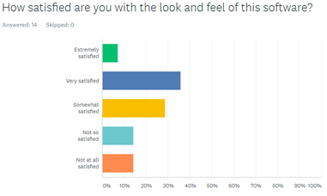

#### **Question 6**

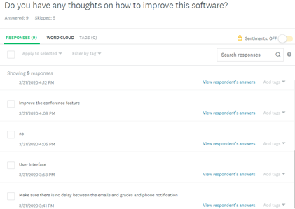

#### **Question 7**

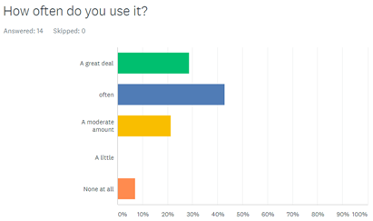

#### **Question 8**

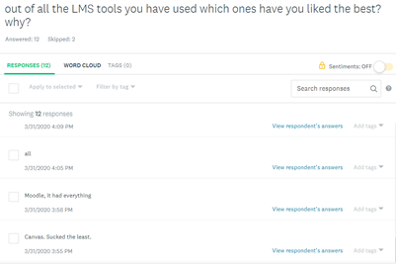

#### **Question 9**

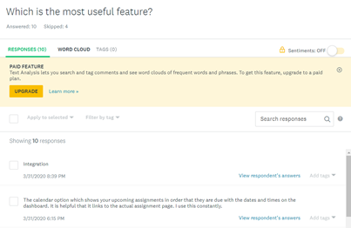

#### **Question 10**

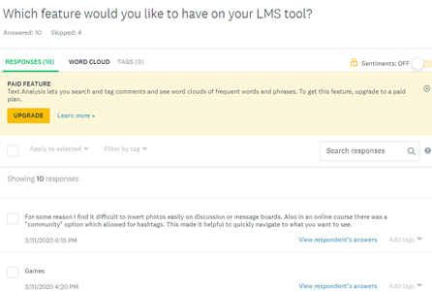

From the statistics and comments provided, we can safely deduce that users want to improve the Communication features and the user interface. While they are satisfied on average, with most of the answers for question 1 ranging between 7 to 10 they would not fully endorse it. One possible theory is that while the software is good, there are better LMS systems out there that meet their communication and user interface needs.

##### **Interview #1**

Adjunct Professor at Yeshiva University who regularly uses canvas for his professional work. He used it before other LMS systems like Blackboard. Comparing them, he feels that Canvas is the easiest one to use, but it's not the best for a quantitative course. The aspect that for him is necessaire to update is the communication with the students. Canvas is a formal platform, and it doesn't allow a more natural approach.

##### **Interview #2**

Student at Yeshiva University who regularly uses canvas for his studies. He was satisfied with Canvas with the most part, and when we asked him how likely he would suggest it, the answer was 8/10. However, he was not happy with the look and feel of the software. When asked which LMS system he prefers, he mentioned Moodle.

Interview conclusion: he likes canvas but not as much as Moodle because the UI feels in Canvas needs improvement.

##### **Interview #3**

Adjunct professor using Canvas only as a professor. He thinks Canvas is useful for teaching for its easy accessibility, but he felt if grading rubric and course material provide a template set will be much more helpful. He would like a focus on communication with the student, but he felt email is much better than its Canvas mail. He has some negative impressions on the file system. He doesn't like that the tool automatically downloads the file selected instead of asking or opening it in the browser.

In conclusion, he said Canvas is good but could be better.

##### **Interview #4**

Program assistant at Yeshiva. He has many experiences in LMS such as NYU Classes and Blackboard besides Canvas. He does not have a particular preference between Blackboard and Canvas. He mainly helped to set up Canvas with many other teaching faculties, and he thought that Canvas is excellent for some instructors on easy attendance checking and grading. Based on some of his experience, some professor was first exposed to Canvas and still requires some extra help on the hotline or so but overall, Canvas is an excellent platform for its smooth learning curve. He thought that the dashboard and its layout could be enhanced. In conclusion, he had a positive impression on it, but it can still be improved a bit.

##### **Interview #5**

Assistant professor at NYU. At NYU the LMS used is a personal one called NYUclasses. Before NYU used Blackboard and she said that she liked it and the new system is comparable to the previous one. She uses it often, and she's happy about it. The only feature that she would like to improve is communication with students but without being too much exposed to notifications.

##### **Interview #6**

Professor at NYU. He uses NYU Classes and before Blackboard. For him, the essential feature is to upload files and manage the assignments. The tool does that in a very efficient way. There is not a discussion option in the LMS, and he would like that enhanced.

He is in general satisfied by the performances of the tool.